Bahria University, Islamabad Campus

Department of Computer Sciences

Mid-Term Examination (Spring-2021)
Class- BS (CS) 4 (A & B)
Paper Type: Subjective

Course: Entrepreneurship Date: 20-05-2021
Course Code: HSS- 421 Time: Session II
Teacher Name: Umm-e-Habiba Max Marks: ______________
Time Allowed 1.5 hrs Total Pages: ______________

Instructions:
- All questions are compulsory.
- There are total three questions.
- The paper is close book.

Student’s Name: MALIK ZOHAIB MUSTAFA Enroll No: 01-134192-030

Question # 1 Marks (8)
- What is Entrepreneurship? (2 Marks)
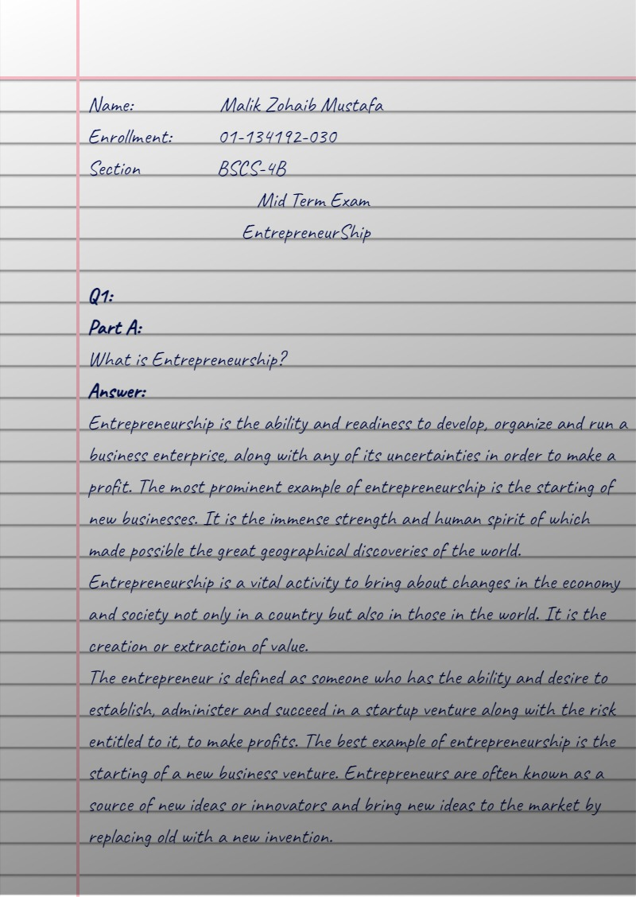

- Describe essential features of an effective business plan? Also, elaborate different types of business plan. (6 Marks)

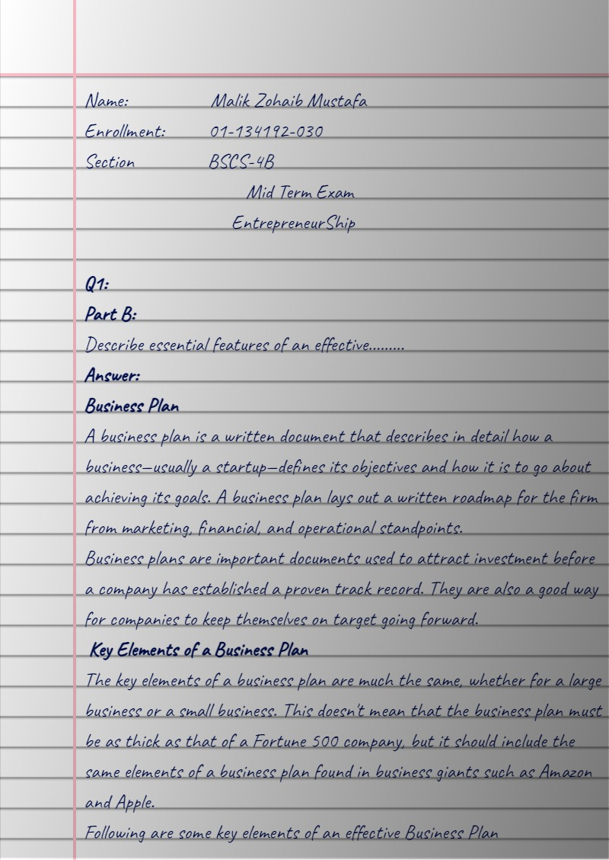

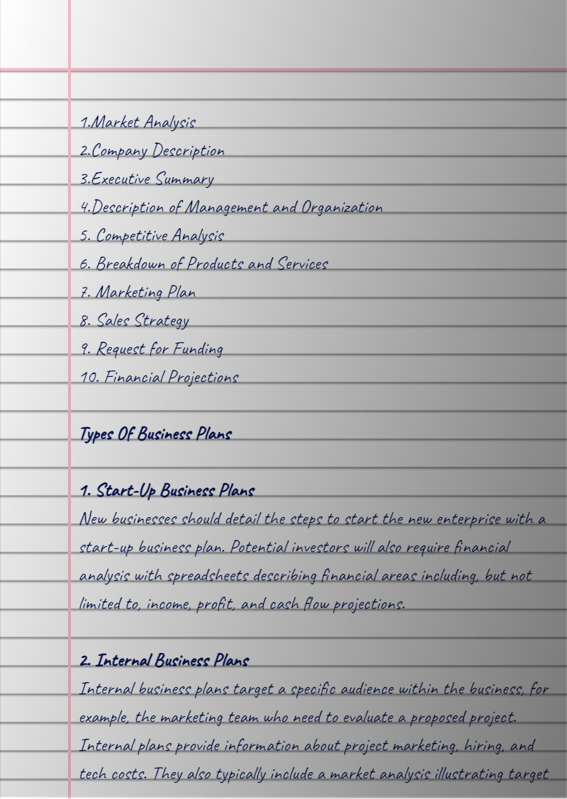

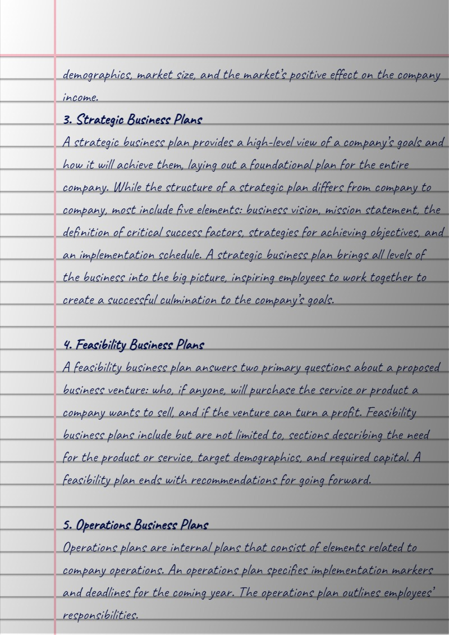
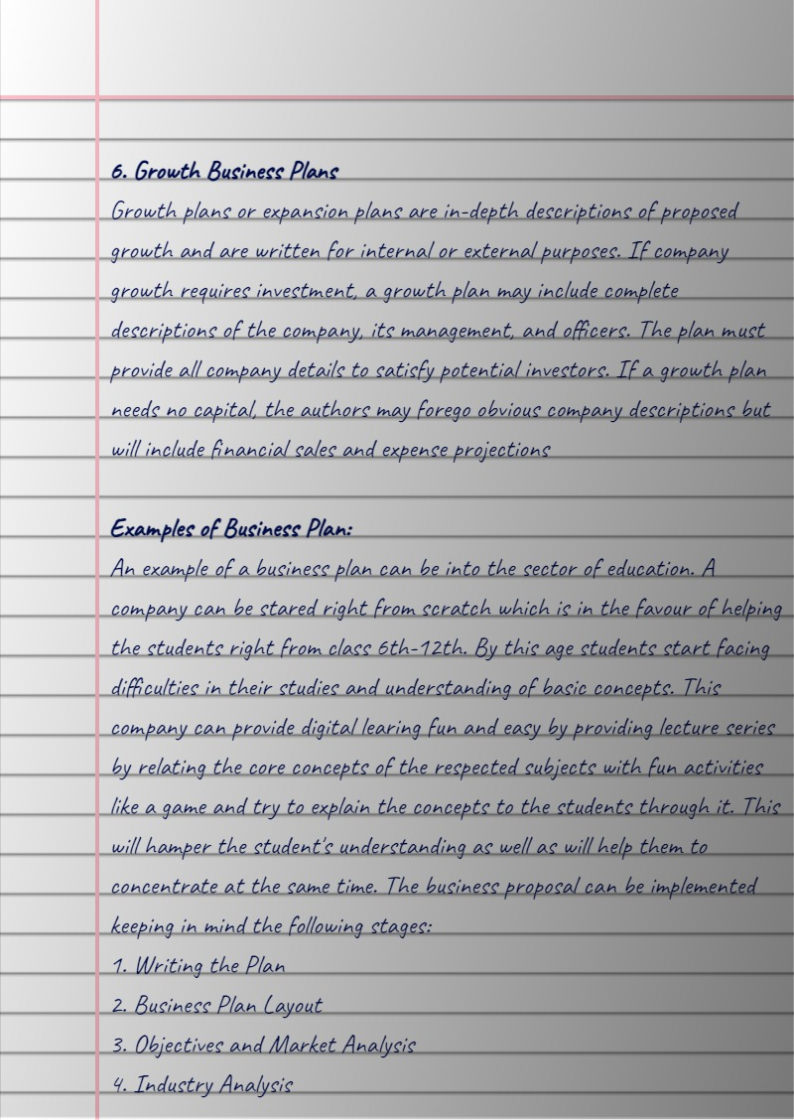

Question # 2 Marks (12)

- Describe the purposes of a product/service feasibility analysis and one primary issue that a proposed business should consider in this area (4 Marks)
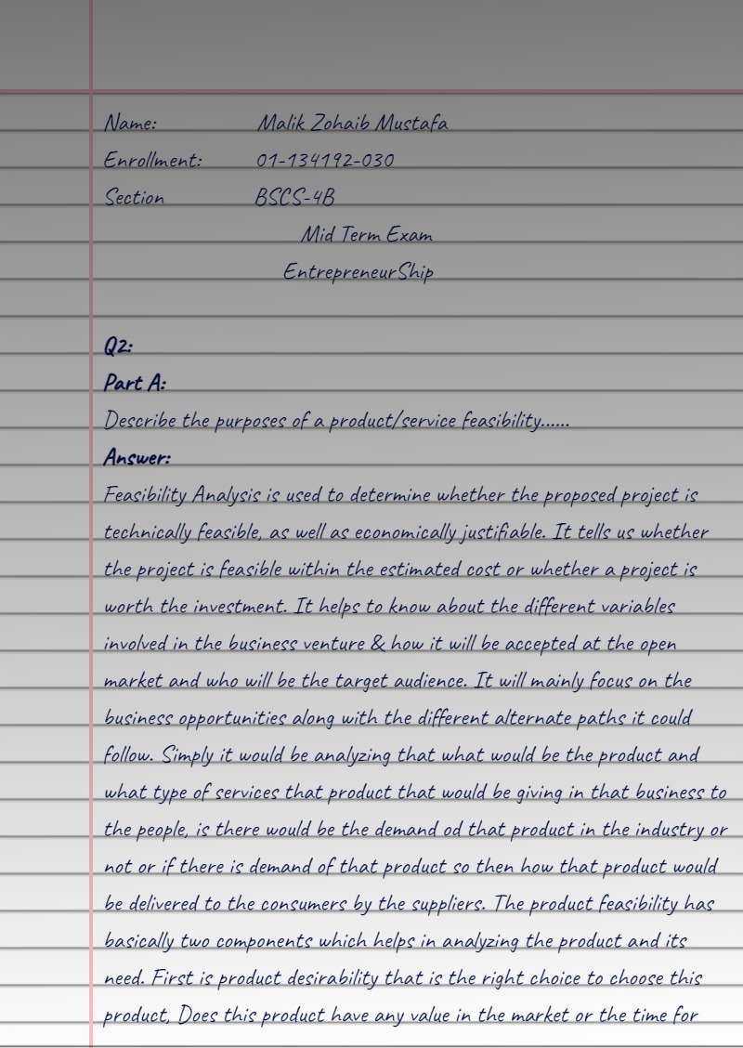
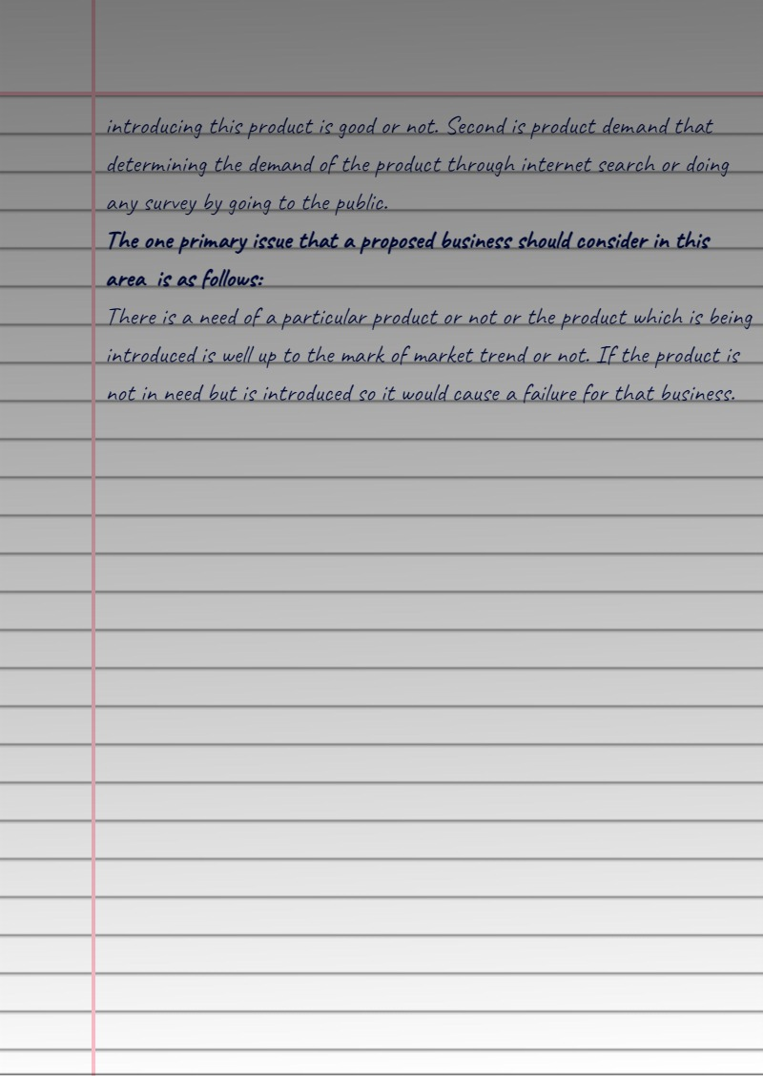

- Due to COVID, the competition in the market is changing the products, services and marketing strategies affect, which are considered as critical for your survival. Whether you are a Fortune 500 company or a small local business, competition has a direct influence on your success. Discuss with the help of example the contribution of Porter's Five Forces model in assessing the attractiveness of the industry in which Five Forces currently operates. (8 Marks)

